**Ans to q 1:**

**System Request - Web-Based Sales System**

**Project Sponsor:** Mr. Mahfuz Hassan , CEO of Som-oy Cars

**Business Need:** This system is created to increase the reach of customers of a local car dealership to a very wide range of people resulting in an increasing amount of sales. Additionally it aims to give a better experience to customers by giving them easy access to all information that they need.

**Business Requirements:** Using this web based system the customers will be able to search, browse and purchase cars easily. Our system should have the following functionalities:

1. Display inventory of all cars with their specifications & price.
2. Customers are able to sort cars based on their preferred brand, color, pricing and should be able to search for a specific one as well.
3. Customers can book a test drive of the car that they want to purchase from the website.
4. Proper customer service live chat service has to be implemented.
5. The system will have an online transaction system so the customer can pay and order the car from home & keep track of the delivery date as well.
6. Customers who have purchased cars should be able to book maintenance appointments.
7. Customers can see others and post their own reviews about the car they bought.

**Business Value:**

There are many tangible and intangible business values that we can expect from this project considering this takes a local dealership to the world wide web. It has a lot of upsides to it.

1. 15% increase in sales and 25% increase in check-ins of the dealership.
2. Customer service review improved by at least two times
3. 10% less expenditure in staff salary
4. 10,00,000 profit per month from car maintenance of customers of other dealerships due to their acknowledgement of our good service.
5. Better reach and more customers.

Special Issues or Constraints:

1. Disclosing lots of information about the business on the internet gives access to information to the competitor businesses as well for which it is always important to keep up with the latest models.
2. Must implement security measures to protect user and website’s confidential data.
3. Need to create a user -friendly interface so that it looks appealing to customers.
4. Need to train the staff for using the system properly.
5. Should be able to handle web traffic.

Q2:

Functional Requirements:

* User Registration: Users should be able to create accounts in the system to place food orders when the exact location will be stored .
* Menu Display: The system should display an up-to-date menu with available food items and their prices.
* Order Placement: Users should be able to select food items from the menu, customize their orders, and place the orders.
* Payment Processing: The system should provide secure online payment options
* Order Tracking: Users should be able to track the status of their orders.
* Order History: Users should have access to their order history
* Customer Support: Users should be able to contact customer support in case of any issues or inquiries.
* Admin: The system should have an admin interface to manage the menu, view orders, manage deliveries etc

Non-functional Requirements:

* Performance:
  + Response Time: The system should respond to user orders within a reasonable time .
  + Scalability: The system should be able to handle big traffic of users and orders.
* Usability:
  + User-Friendly Interface: The system should have an intuitive and easy-to-use interface for users.
  + Accessibility: The system should be accessible to all users nearby in the campus and restricted if the delivery order is not in campus.
* Security:
  + Privacy: The system secures personal information, payment details, and order history.
  + Payment Security: secure payment methods to protect payment information.
* Reliability:
  + Availability: The system should be available for users to place orders and track their status reliably during designated operating hours.
  + Error Handling: The system should handle errors gracefully, providing appropriate error messages and taking necessary actions to recover from failures.
* Operational:
  + The system should run on mobile devices for instant use.
  + The system should integrate with existing systems, such as inventory management and delivery management systems.

ANS TO Q 3:

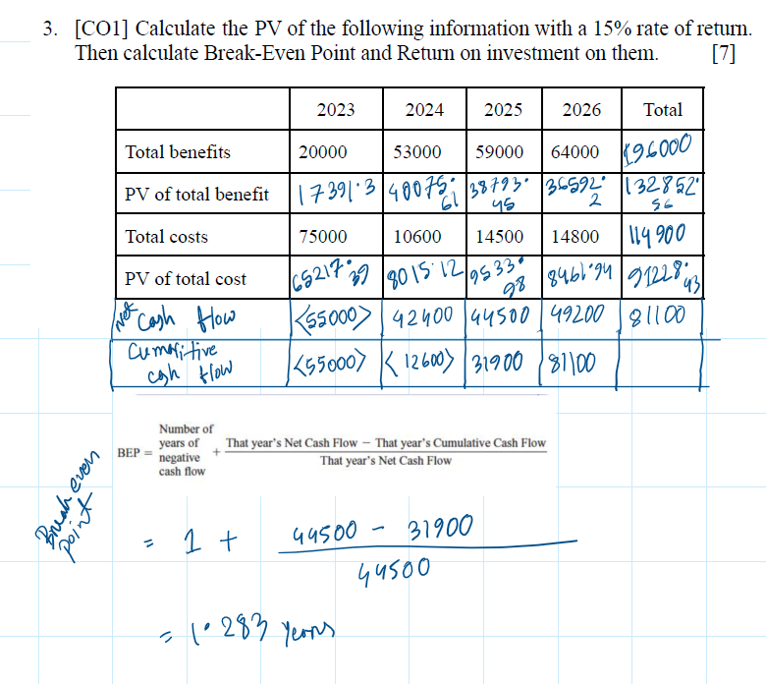

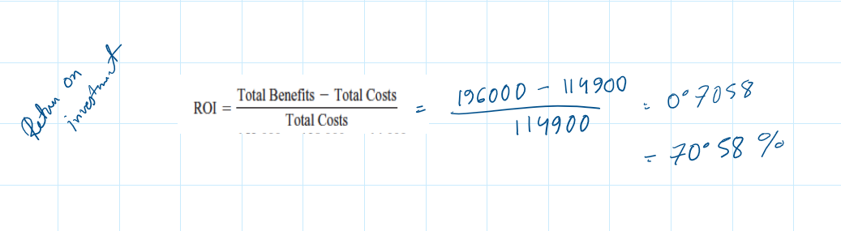

ASS 2:

QUESTION 2:

Sample:  
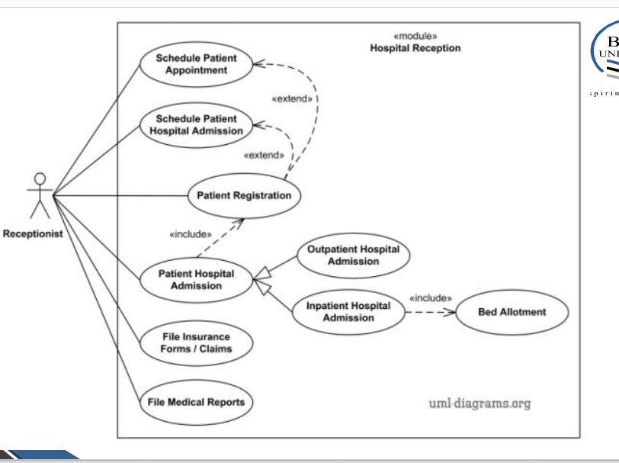

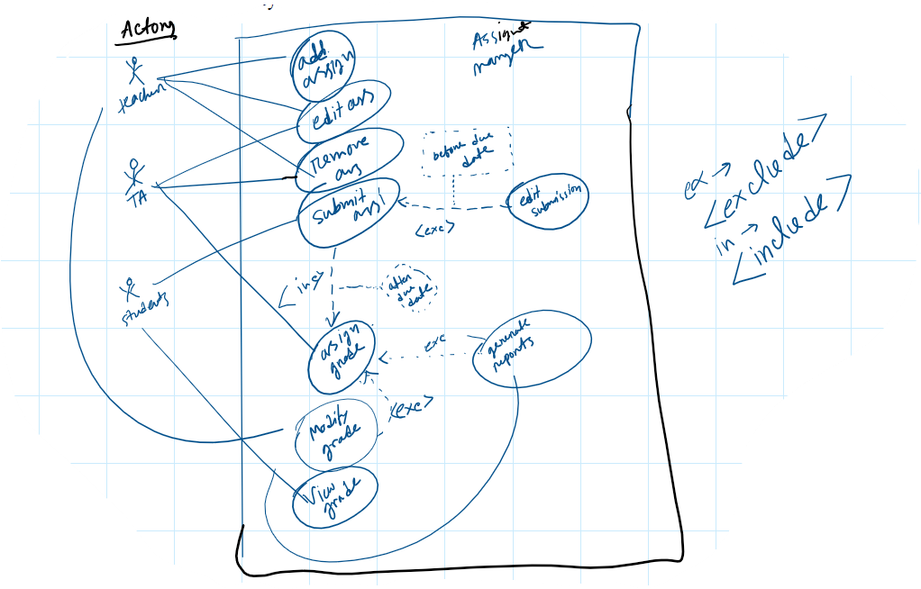

SAMPLE USE CASE DESCRIPTION:

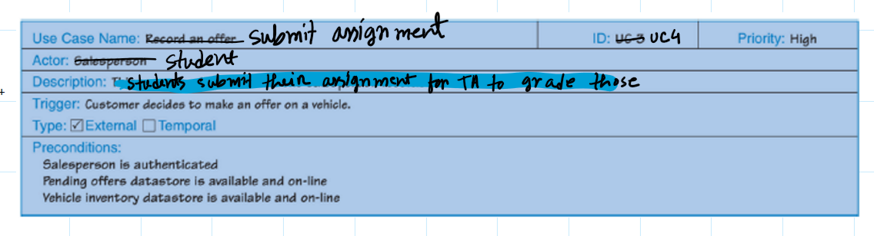

QUESTION 2: ii)

* Use Case Name: Submit Assignment
* Use Case ID: UC01
* Actor: Student (Primary Actor)
* Description: This use case represents the process by which a student submits an assignment assigned by teacher and for TA to grade before the due date.
* Precondition: The student must be enrolled in the course and have access to the assignment. The assignment submission period must be open.
* Postcondition: The student submitted the assignment and is able to edit the submission and the submission is recorded by the system.
* Action Flow:
  + The student navigates to the assignment section.
  + The student selects the assignment they want to submit.
  + The student uploads the required files or documents.
  + The student confirms the submission.
  + The system records the submission.

Exceptions:

* + If the submission period has expired, the system displays an error message.

Use Case 2: Assign Grade (Teaching Assistant)

* Use Case Name: Assign Grade
* Use Case ID: UC02
* Actor: Teaching Assistant (Primary Actor)
* Description: This use case represents the process of a teaching assistant assigning a grade to a student's submitted assignment after the assignment's due date.
* Precondition: The TA has the necessary access to grade assignments. After the assignment's due date has passed, submissions are available for grading.
* Postcondition: The TA’s assigned grades are recorded by the system and open for teachers to modify those.
* Action Flow:
  + The TA accesses the grading interface for the assignment.
  + The teaching assistant selects a student's assignment for grading.
  + The teaching assistant evaluates the assignment and assigns grades.
  + The system records the assigned grade and notifies the teachers.
* Exceptions:
  + If the assignment's due date has not passed, the system displays an error

Q2 iii)

* Teacher (Primary Actor)
* Teaching Assistant (Primary Actor)
* Student (Primary Actor)

Q1:i) view schedule, player profile, Team profiles,

match details.

Actor: user- premium user, regular user

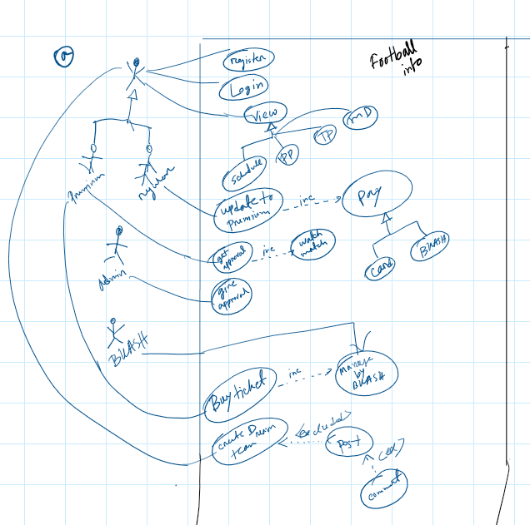

Q1 ii)

Use Case 1: Update to Premium

* Use Case Name: Update to Premium
* Use Case ID: UC01
* Actor: Regular User (Primary Actor)
* Description: User updates their status to Premium by paying a fee by BKASH or Credit Card and gets Premium access.
* Precondition: The user must be a regular user, be registered and logged in to the website.
* Postcondition: The user becomes a premium user and has access to Premium-only features.
* Action Flow:
  + The user navigates to the Premium upgrade section and selects upgrade.
  + The system displays the payment options, including BKASH and Credit Card.
  + After the user completes payment, the system verifies the payment and updates the user's status to Premium.
* Exceptions:
  + If the payment process fails or encounters errors, the system displays an error message.

Use Case 2: Create Dream Team

* Use Case Name: Create Dream Team
* Use Case ID: UC02
* Actor: User (Primary Actor)
* Description: The user selects their team name, manager, preferred players, assigns positions to create their own dream team .
* Precondition: The user must be registered and logged in to the website.
* Postcondition: After creating a dream team the user can share it on the website for others to see and comment on.
* Action Flow:
  + The user goes to the Dream Team creation section.
  + The user selects their desired players, assigns positions to each player, and creates their dream team .
  + The user provides a name and description for their dream team.
  + The user confirms the dream team for creation.
  + The system saves the dream team.

iii)

Actors:

1. Users, Regular users, premium users- Primary actors
2. Admin - secondary actors
3. BKASH- other system